**Objective**:

We need you to develop an **AI based Chatbot (mobile/web app)** to create answers to queries **based on FAQs and more FAQs getting automatically added including** categorization. You can **use machine learning algorithms** to increase the dataset of questions and answers and ensure that the mapping of questions and answers remain maintained every time there is an increase in the dataset."

**Introduction:**

What is FAQ chat bot?

ChatBot is a software application used to conduct an on-line chat conversation via text or text-to-speech, in instead of providing direct contact with a live human. However, An FAQ (Frequently Asked Questions) chatBot is a type of internet bot or software application that is beneficial for answering some of the most frequently asked questions your...

Businesses publish FAQ sections to answer frequent user questions, however, users may have a hard time getting their questions answered because of reasons such as:

· They do not use the exact same words as in the frequently asked question. This can stop them from finding the right answers if the website uses simple search functions.

· Their question may involve a combination of questions which can result in a lengthy answer

· The FAQ section may not be mobile friendly

· They may just not like using FAQs and prefer a chat-like interface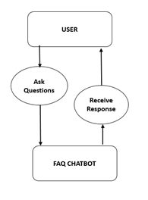

FAQ chatbots aim to resolve these problems by using NLP capabilities and providing answers in an intuitive chat interface. To build FAQ chatbots, chatbot vendors:

Crawl company’s website for information

Use the crawl data to build an initial bot

Enable users to make changes to automatically built bot

via a user interface

AI /Machine learning Algo :-

**The main algorithm that's used for making chatbots is the “Multinomial Naive Bayes” algorithm. It is used for text classification and natural language processing (NLP). Both of these are important components of any AI chatbot.**

**MULTINOMIAL NAIVE BAYES:-**

Multinomial Naive Bayes algorithm is a probabilistic learning method that is mostly used in Natural Language Processing (NLP). The algorithm is based on the Bayes theorem and predicts the tag of a text such as a piece of email or newspaper article. It calculates the probability of each tag for a given sample and then gives the tag with the highest probability as output.

**Naive Bayes classifier** is a collection of many algorithms where all the algorithms share one common principle, and that is each feature being classified is not related to any other feature. The presence or absence of a feature does not affect the presence or absence of the other feature.

**Benefits of FAQ Chatbot over real-time support:-**

1. Available 24×7

2. Cuts down operational cost

3. Offers personalized experience

4. Monitors customer data and gives better insights

5. Automates repetitive tasks

**Implementation**:

· Technology

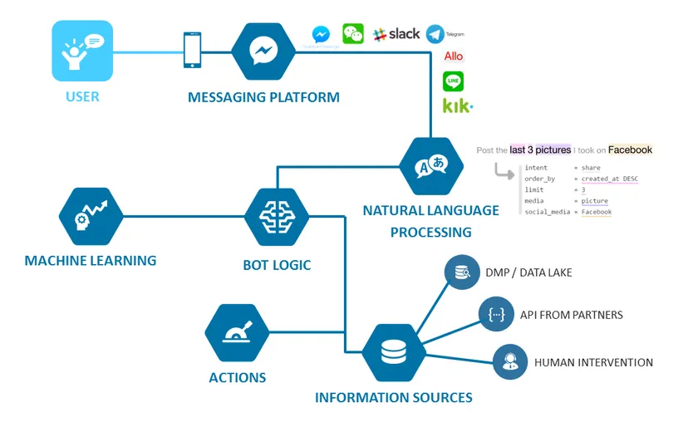

**FIND ANSWER OF THE FOLLOWING QUESTIONS:**

* **How to build a chatbot ?**
* **How will a chat bot answer the asked question?**
* **Which concept will be used?**

· Framework

· Software used: